Problem: For each of the following flowcharts identify the problems, correct them, and
describe in your own words what the flowchart is doing.
1.
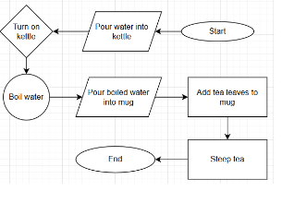
Expected answer:
- Identify problems
- Turn on kettle: incorrect symbol should be parallelogram
- Boil water: incorrect symbol should rectangle
- Add tea leafs: incorrect symbol should parallelogram
- Does not read easily, should be top-down, left to right
- Fix
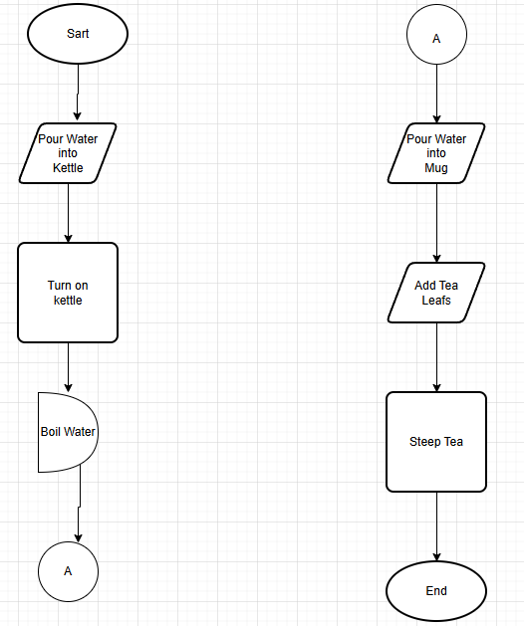
- Describe process in own words
This flowchart describes the process of making a cup of tea. Place water into the kettle and turn on. Wait until the water boils. Pour the boiled water into your mug.
Add the tea leaves and let steep.

Problem 2:
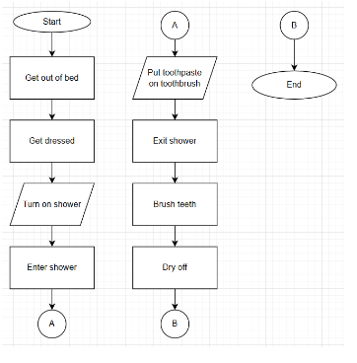
- Problems:
The solution is out of order
Unnecessary on page B connector

2.Fix
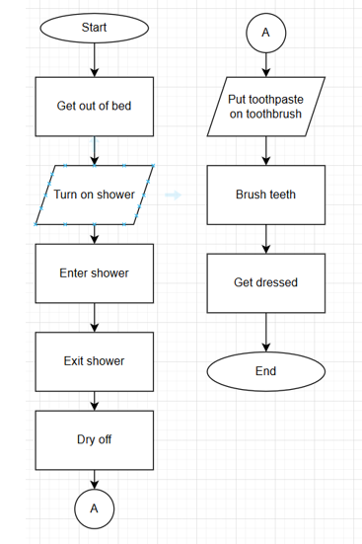

3 Describe problem in own words
This flowchart describes the process of getting ready for the day. It includes getting up, showering, clearing one’s teeth, and getting dressed.

